67-jenkins-into to 77th

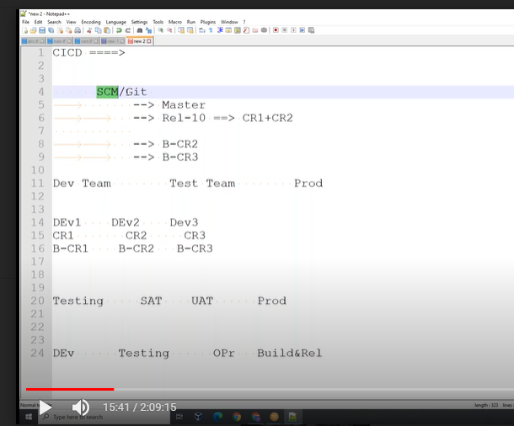

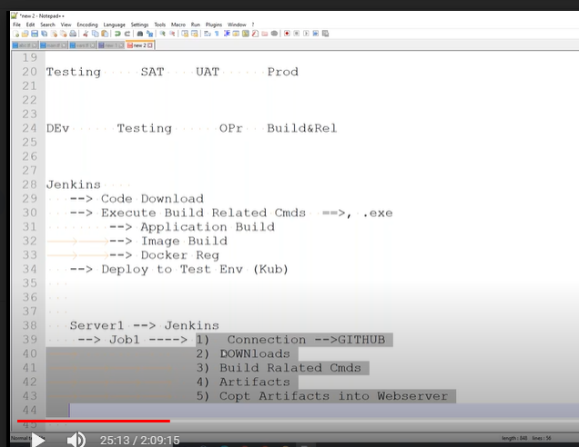

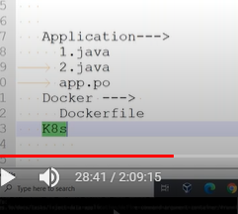

Ci/cd—process steps below

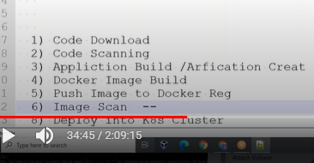

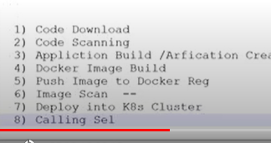

Branching sttagiy

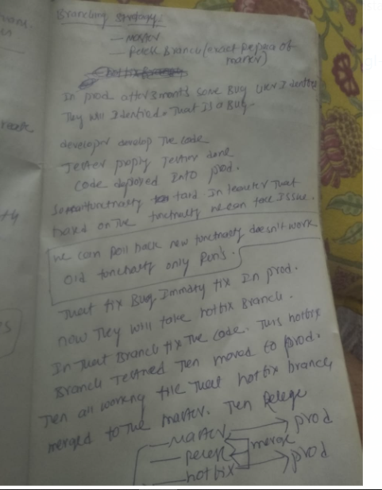

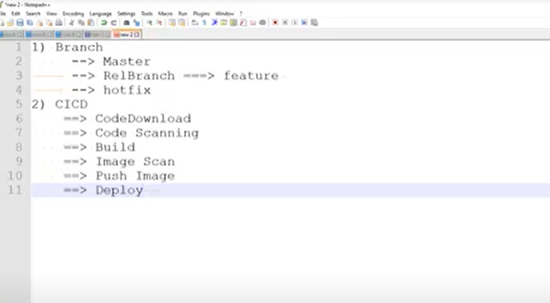

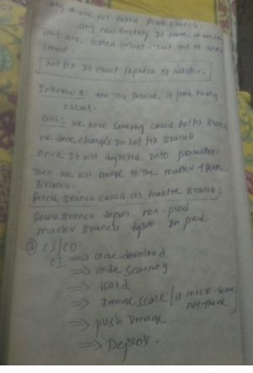

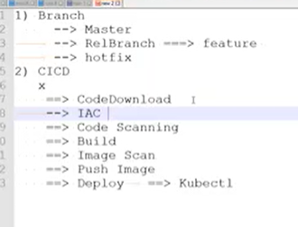

Install Jenkins

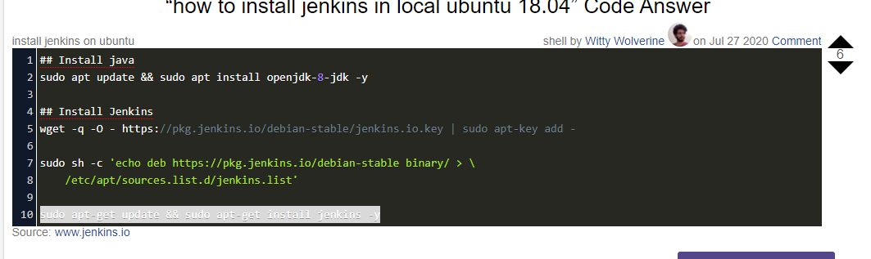

## Install java

sudo apt update && sudo apt install openjdk-8-jdk -y

## Install Jenkins

wget -q -O - https://pkg.jenkins.io/debian-stable/jenkins.io.key | sudo apt-key add -

sudo sh -c 'echo deb https://pkg.jenkins.io/debian-stable binary/ > \

/etc/apt/sources.list.d/jenkins.list'

sudo apt-get update && sudo apt-get install jenkins –y

service Jenkins status

588dbba3f3624c50836a3906621d916d

master will shudled your job in slave machine

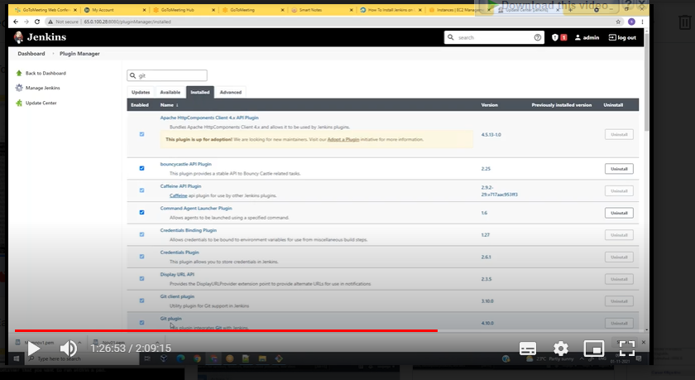

Prient env: environment variable’s

Build number nothing but the job name.

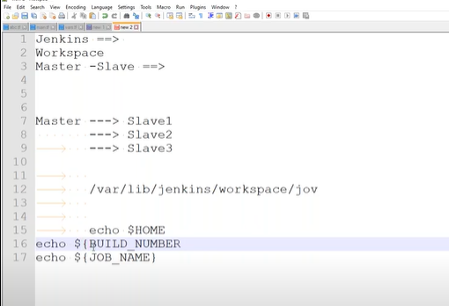

pwd

echo this is my first jon

cp /etc/passwd .

whoami

echo ${var_1}

if 1st command failed it is not goto 2nd command.

./1.sh

ca-certificates \

curl \

gnupg \

lsb-release

curl -fsSL https://download.docker.com/linux/ubuntu/gpg | sudo gpg --dearmor -o /usr/share/keyrings/docker-archive-keyring.gpg

echo \

"deb [arch=$(dpkg --print-architecture) signed-by=/usr/share/keyrings/docker-archive-keyring.gpg] https://download.docker.com/linux/ubuntu \

$(lsb_release -cs) stable" | sudo tee /etc/apt/sources.list.d/docker.list > /dev/null

sudo apt-get update

sudo apt-get install docker-ce docker-ce-cli containerd.io

**we can put all code into one file 1.sh**

**we are having one-job multiple builds**

